Quadruped-Master



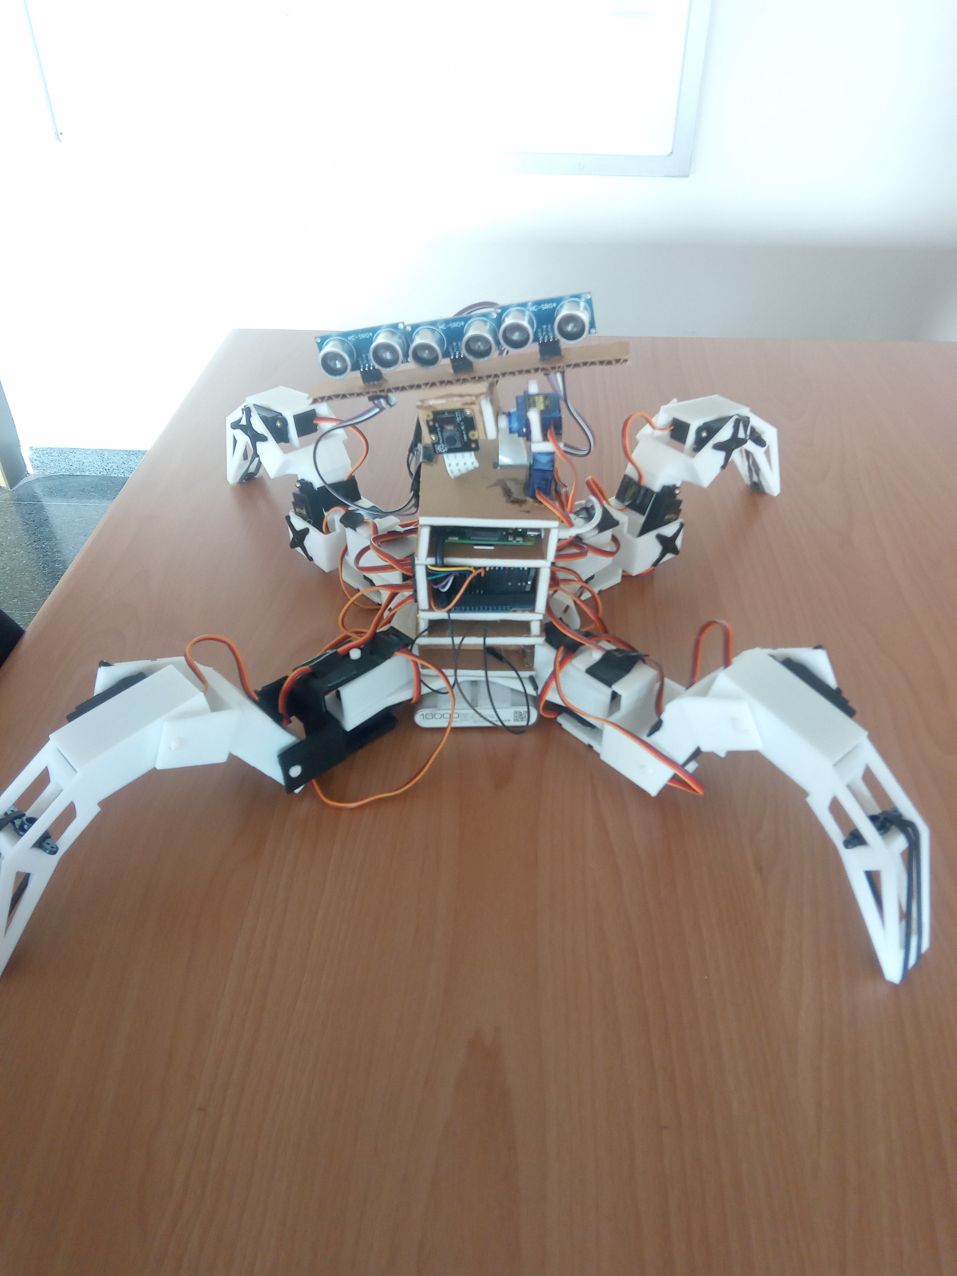

# Description

Four legs robot made by Edgar Gracia and Eduardo Flores. It’s a robot that use 12 servomotors to move it’s 4 legs. It’s controlled by a computer, connected by Wi-Fi. It walks as commanded and move the camera also as commanded, the images recorded by the camera are send to the computer.

# Necessary Material

In order to use this robot some extra stuff is needed.

* 1. 8 AA Batteries of 1’2V each
  2. Power Bank Battery
  3. Laptop with the following:
     1. Wi-Fi connection module
     2. Python on it
  4. The “Control.py” program you’ll find in GitHub, following the QR on the top of this page.

# Instructions

To switch on the quadruped, first be sure it is in the initial position. With all 4 legs looking on their diagonals and closed. As in the picture:

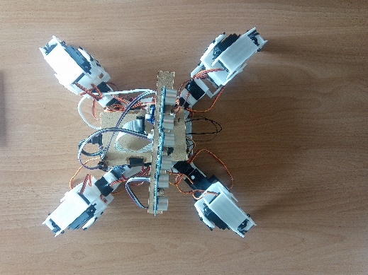

Plug the batteries to connect the servomotors. There are 2 battery cases, and the cables are following the next sequence:

The Robot black cable has to be connected to the batteries red and black cable. It’s the Ground.

The Robot Brown cable has to be connected to the batteries green cable. It’s the power.

Plug the battery to connect the Raspberry and Arduino. This is a power bank battery, attached in the bottom belly of the robot.

After the robot is all connected with the laptop connect to the “RaspiAP” Wi-Fi connection. Then run the program called “Controller.py” and a screen must appear.

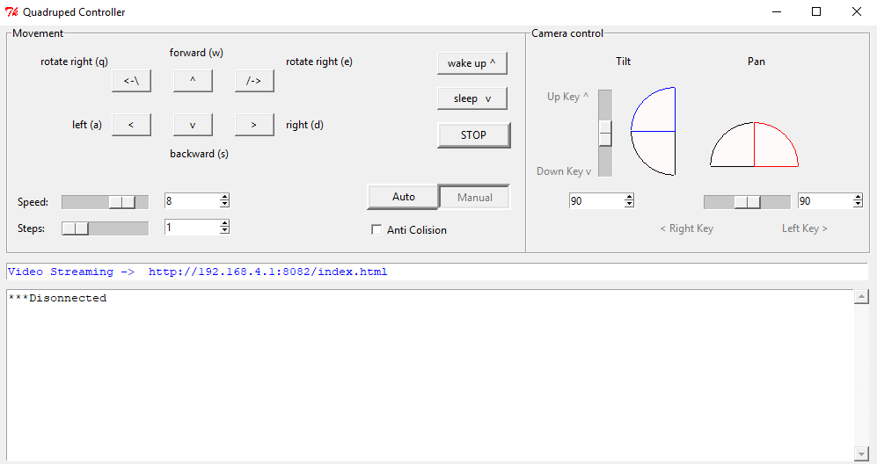With this you should be able to control the robot following the instructions below.

The Movement Box controls all the move motion, rotate right and left made the robot rotate in the same spot. Forward, backwards, left and right moves the robot in the direction described.

Speed controls the robot moves speed and Steps control how many steps in that direction the robot has to make. For example, if steps it’s set at 5 and you press forward, it’ll make 5 steps forwards.

Wake up makes the robot stand in its legs and sleep makes it rest its belly on the ground.

STOP, Auto and Manual are not implemented yet so they are of no use.

The Camera control box controls the orientation of the camera, Tilt and Pan control the vertical and horizontal angle respectively.

To see the video of the camera you have to go to your internet browser and input the address showed in the control screen (Video Streaming).

# Technical Section

## Known Issues

If the robot servos are not well powered they will make uncontrollable moves and you’ll not be able to move it. To prevent this, make sure the batteries are charged.

One of the pieces that makes the legs is not strong enough and it can brake easily. If it breaks it can be easily glued with superglue or some similar glue.

## Possible Next Steps

It was thought to make the robot move by itself, using the ultrasounds distance sensors to detect the objects around, but for the moment it’s not implemented, just the switch in the interface.

Build a new chassis for the Arduino, the batteries and the raspberry 3D printed and also new pieces for the camera and ultrasound sensors also 3D printed.